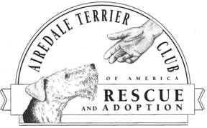

NATIONAL AIREDALE TERRIER RESCUE Rusty LaFrance ~ Microchip Program
(Non Profit Organization 501 (c)(3) Coordinator
Employee Identification Number: 27-0054363
DLN: 17053239043043

8524 Maggie Avenue * Las Vegas, Nevada 89143
702-656-2736 fax: 413-556-0827 email: rusty@codusa.com
http://www.airedalerescue.net

Dear Doctor:

Thank you very much for assisting our rescue volunteer.

As of 2005, National Airedale Rescue, Inc., has set as its goal that every Airedale rescued be identified by a microchip.

To that end, we have purchased 2600 microchips from Home Again so far, in our capacity as a National Rescue Group, and are providing them to our volunteers at no cost to them.

We ask that you implant the microchip as part of your normal exam of the rescued Airedale at no charge. (Nothing more than the injection of the chip, provided by the Volunteer, is required from you.)

Thank you very much for your cooperation. We would not be able to carry on our work without the assistance of caring medical professionals like yourself.

Sincerely,

Rusty LaFrance
Coordinator of Microchip Program
NAR, Inc.

